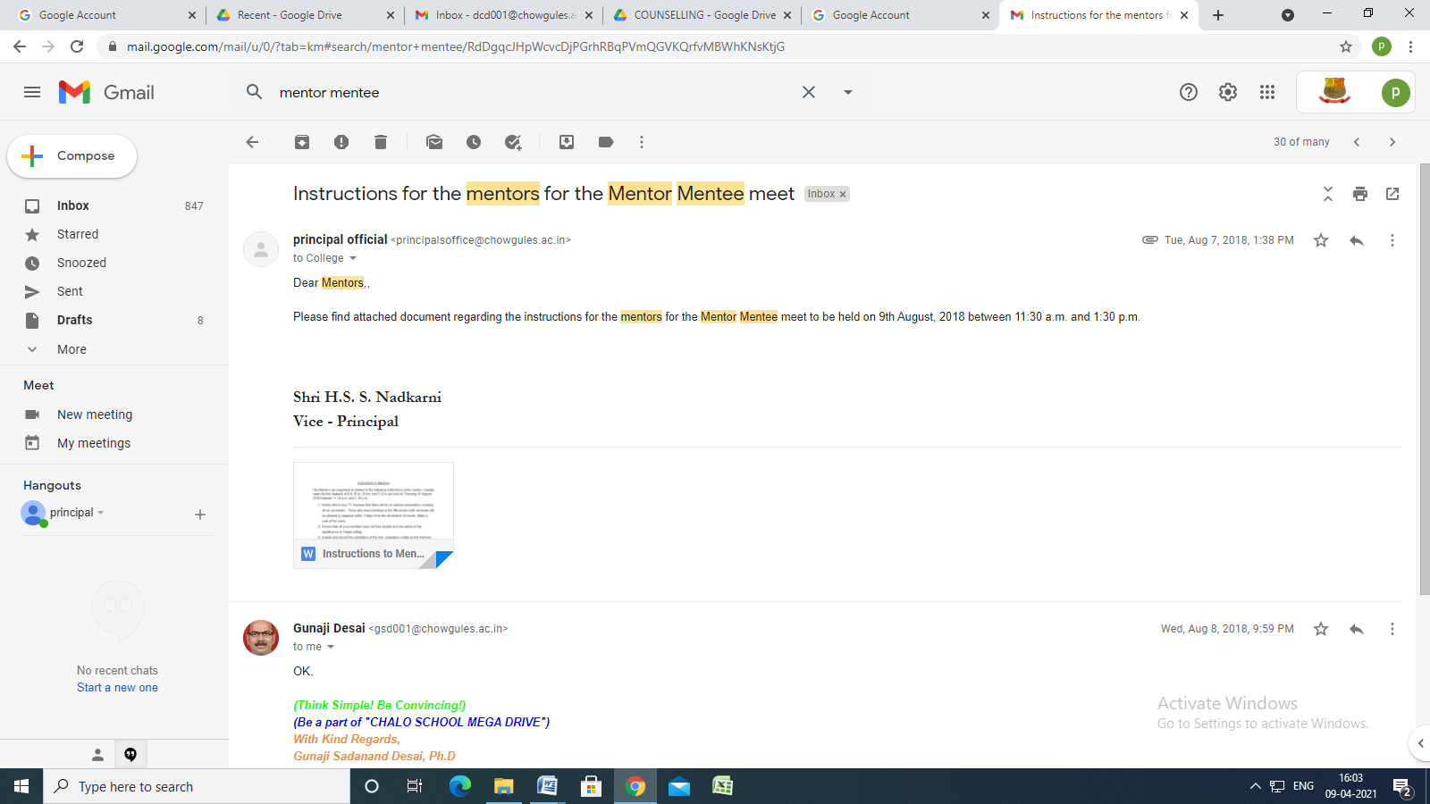

Instructions for the mentors for the Mentor Mentee meet
Inbox
principal official <principalsoffice@chowgules.ac.in> | Tue, Aug 7, 2018, 1:38 PM
to College

Dear Mentors,,

Please find attached document regarding the instructions for the mentors for the Mentor Mentee meet to be held on 9th August, 2018 between 11:30 a.m. and 1:30 p.m.

Shri H.S. S. Nadkarni
Vice - Principal

Instructions to Mentors
The Mentors are requested to adhere to the following instructions at the mentor- mentee meet (for the students of B.A, B.Sc, B.Voc and P.G) to be held on Thursday 9th August 2018 between 11:30 a.m. and 1.30 p.m.:
- Kindly inform your TY mentees that there will be no special examination covering all six semesters. Those who have backlogs in the fifth and/or sixth semester will be allowed to reappear within 15days from the declaration of results. Make a note of the same.
- Ensure that all your mentees have set their targets and are aware of the significance of Target setting.
- Inquire and record the completion of the non- evaluative credits by the mentees (Number).
- Advise on the importance of maintaining regular attendance for lectures and practicals.
- Inquire about the progress/performance at the last SEE and current CAs. Make a note of the same.
Make sure the mentees have filled in the requisite information in the form provided to them on the college website. This form was regarding the mentoring program. Follow these steps to view the mentoring form
Step 1: Login to Autonomy Login
Step 2: Click on TASK
Step 3: Click on TARGET
Step 4: Click on View to view mentoring form

- Distribute the Planners to the mentees
NOTE: A report of the mentor-mentee meet should be sent as per the format available at https://goo.gl/forms/7BEjGfzbVAYPk5AP2.The last date of submission is Thursday 16th August 2018.

